Program Structures and Algorithms

Spring 2023(SEC –03)

NAME: Yufan Gao

NUID: 002755691

**Task:**

In this assignment, your task is to determine--for sorting algorithms--what is the best predictor of total execution time: comparisons, swaps/copies, hits (array accesses), or something else.

You will run the benchmarks for merge sort, (dual-pivot) quick sort, and heap sort. You will sort randomly generated arrays of between 10,000 and 256,000 elements (doubling the size each time). If you use the SortBenchmark, as I expect, the number of runs is chosen for you. So, you can ignore the instructions about setting the number of runs.

For each experiment (a sort method of a given size), you will run it twice: once for the instrumentation, once (without instrumentation) for the timing.

Of course, you will be using the Benchmark and/or Timer classes, as you did in a previous assignment.

You must support your (clearly stated) conclusions with evidence from the benchmarks (you should provide log/log charts and spreadsheets typically).

**Relationship Conclusion:**

The execution time is determined by:

MergeSort Dual Pivots algorithm: Swaps.

QuickSort Dual Pivots algorithm: Compares and Swaps.

HeapSort Dual Pivots algorithm: Compares and Swaps.

**Evidence to support that conclusion:**

MergeSort:

|  |  |  |  |  |
| --- | --- | --- | --- | --- |
| ***Size*** | ***Compares*** | ***Swaps*** | ***Copies*** | ***Time/ms*** |
| 10000 | 123592 | 9792 | 109952 | 3.86 |
| 20000 | 267068 | 19618 | 239892 | 5.71 |
| 40000 | 573860 | 39009 | 519824 | 12.05 |
| 80000 | 1227739 | 77640 | 1119562 | 25.87 |
| 160000 | 2616482 | 155886 | 2399229 | 56.2 |
| 256000 | 4360345 | 224333 | 4049601 | 100.88 |

HeapSort:

|  |  |  |  |  |
| --- | --- | --- | --- | --- |
| ***Size*** | ***Compares*** | ***Swaps*** | ***Copies*** | ***Time/ms*** |
| 10000 | 235313 | 124201 | 0 | 3.41 |
| 20000 | 510804 | 268383 | 0 | 5.87 |
| 40000 | 1101458 | 576834 | 0 | 13.6 |
| 80000 | 2362696 | 1233277 | 0 | 29.98 |
| 160000 | 5046279 | 2627405 | 0 | 68.56 |
| 256000 | 8410813 | 4372061 | 0 | 141.04 |

QuickSort:

|  |  |  |  |  |
| --- | --- | --- | --- | --- |
| ***Size*** | ***Compares*** | ***Swaps*** | ***Copies*** | ***Time/ms*** |
| 10000 | 151787 | 62014 | 0 | 2.12 |
| 20000 | 338489 | 143257 | 0 | 3.46 |
| 40000 | 712249 | 312090 | 0 | 8.23 |
| 80000 | 1534839 | 626596 | 0 | 19.22 |
| 160000 | 3265825 | 1377444 | 0 | 43.92 |
| 256000 | 5525002 | 2190632 | 0 | 72.22 |

**Graphical Representation:**

MergeSort:

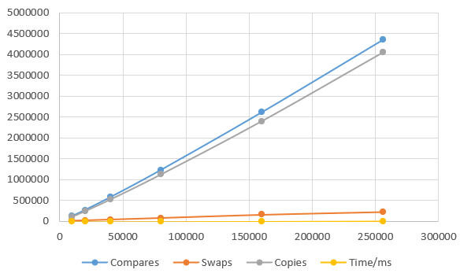

HeapSort:

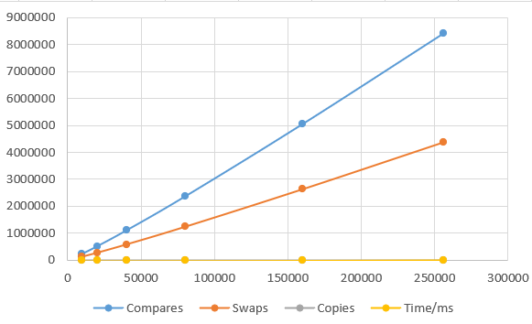

QuickSort:

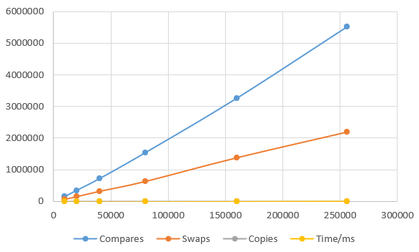

**Unit Test Screenshots:**

